Project Profile

* Project Profile
* **Project Name:-** Sherwani shop
* **Type of application :-** web Application
* **Project Description :-**

This website is developed for shopping of the customer. It provides sherwani. It also provide’s sherwani to customer this web site it requires only booking of the buyers which is also paybal.

* **Project information:**

Definition :- Online Shopping site

Platform :- Windows

Frontend :- Html , Php , Css

Backend :- My Sql

Web Server:- Apache , Nginx

Web Browser:- Google Chrome , Safari , Firefox

Developed By: - Harsh Zankat

SYSTEM STUDY

* System Study
* Existing System:
* Study of current system: -

This project is developed to sell the

products online of various sherwani.

* Problems and weakness of the system: -

The user can save his or her time by

Purchasing the product which time they are wasting by roaming in the market. From here, they

Can get most probably all the things they want besides fast moving entertainment goods. They have various choice sin the one collection.

* Proposed System:
* In this system different modules are available which all uses all uses are as an activity in this web application project or system, these modules are as follows :
* Login
* Registration
* Category
* Products
* Add to cart
* Shopping
* Delivery details
* About us
* Aim and objective of the proposed system:
* User can access easily this website.
* The user can save his or her time by purchasing the product which time they are wasting by roaming in the market.
* Product in reasonable price.
* Application feature:
* Welcome slider for all items.
* List of all categories sherwani to show.
* Improve the existing system.
* Delivery product live location share.
* Feasibility Study

* Operational Feasibility:-

The web application working is quite easy to use and learn due to its simple but attractive interface. User requires no special Training for operating the web application.

* Technical Feasibility: -

The technical requirement for the web application is economic and it does not use any other additional hardwere and software ,the system can be expanded by adding new feature if necessary in future.

* Economical Feasibility:-

The application being developed is economic with respect to user point of view. The result obtained contains minimum errors and are highly accurate as the data is required.

SYSTEM ANALYSIS

* System Analysis
* Requirement Specification: -

During implementation the following tools have been used to develop the website and perform necessary testing.

|  |  |
| --- | --- |
| **Google Chrome** | **Firefox** |
| Web site Security and privacy week then  Firefox. | Web site Security and privacy best then google crom. |
| Chrome is significantly faster and more memory efficient then fire fox. |  |
| Your device can access in google crom. |  |
|  |  |

* System Modules:
* Admin Modules: -

1. Login
2. Manage Product
3. Manage order
4. Manage Category
5. Manage User
6. Manage account details
7. Manage feedback

* User Modules:

1. Registration
2. Login
3. Forget Password
4. Manage Details
5. Wishlist
6. Add to cart
7. Product Details
8. Payment details
9. Order Detalis

DIAGRAMS

* Admin side Diagrams
* Module Hierarchies: -

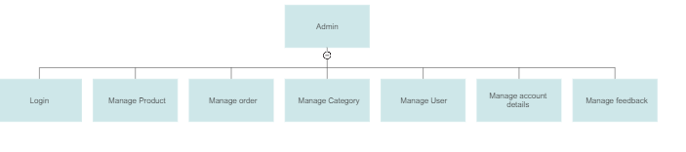

* Activity Diagram: -

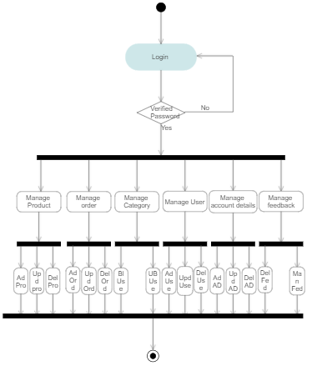

* Use case Diagram: -

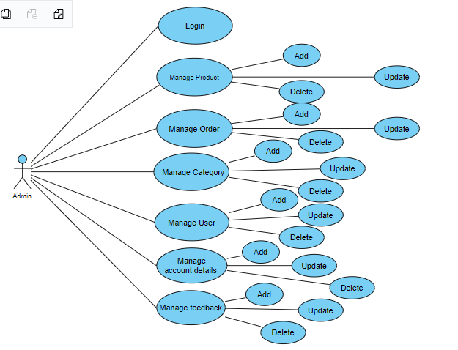

* User Side Diagrams
* Module Hierarchies: -

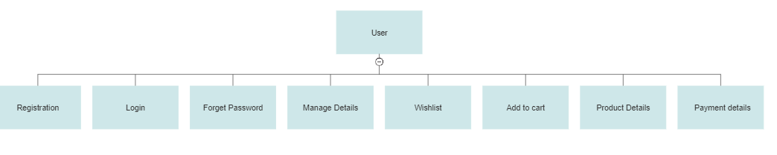

* Activity Diagram: -

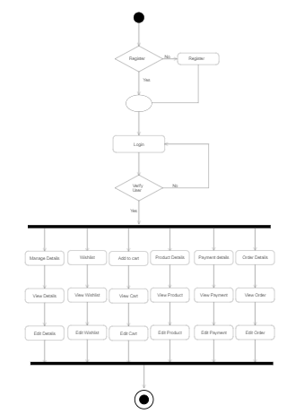

* Use case Diagram: -

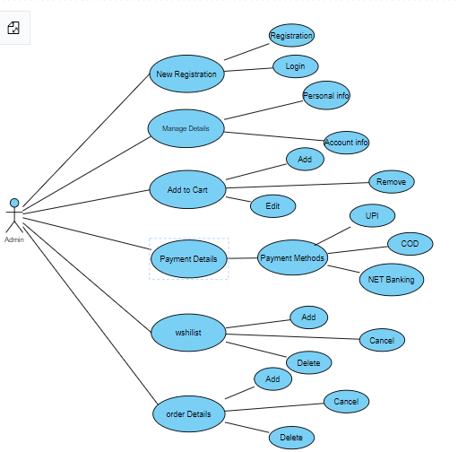

DATA DICTIONARY

* Data Dictionary
* Login: -

|  |  |  |  |
| --- | --- | --- | --- |
| **Column**  **Name** | **Data Type** | **Constraint** | **Description** |
| Login Id | Integer(15) | Primary Key | All Login Id is Different |
| Password | Varchar(6) | Not Null | Minimum 6 Digit Must be Added |

* Categories**:-**

|  |  |  |  |
| --- | --- | --- | --- |
| **Column**  **Name** | **Data Type** | **Constraint** | **Description** |
| Category Id | Integer(10) | Primary Key | All Category id is different |
| Category Name | Varchar(50) | Not Null | This filed shows the Category name |
| Category Types | Varchar(10) | Not Null | This Filed shows of Categories |

* Products:-

|  |  |  |  |
| --- | --- | --- | --- |
| **Column name** | **Data Type** | **Constraint** | **Description** |
| Product Id | Integer(30) | Primary key | All Product id is different |
| Product Name | Varchar(30) | Not null | It’s shows name of the of product |
| Product Type | Varchar(30) | Not null | It’s shows name of the of product |

* Payment:-

|  |  |  |  |
| --- | --- | --- | --- |
| **Column Name** | **Data type** | **Constraint** | **Description** |
| Payments Id | Integer(20) | Primary Key | All Payment id is different |
| Payments Details | Varchar(12) | Not null | it’s shows details of the payments |
| Payments Method | Varchar(12) | Not null | it’s shows details of the payments |

* User Account Data:-

|  |  |  |  |
| --- | --- | --- | --- |
| Column Name | Data Type | Constraint | Description |
| User id | Integer(12) | Primary Key | Every user id is different |
| User name | Varchar(12) | Not null | It’s show name of the user |
| Password | Varchar(12) | Not null | Minimum 6 Digit Must be Added |
| Mobile no | Integer(10) | Not null | It’s shows mobile number of the user |
| Wishlist | Varchar(20) |  | It’s show Wishlist of the User |
| Delivery | Varchar (20) | Not null | If You Buy |
| Details | ------ |  | Anything in our website you must add your delivery address |
| About Website | Varchar (300) | Not null | It’s shows information terms and condition, deals, offers and many more |